Using direct square of absolute difference accuracy-----------------------------------------------------------

# error = numpy.mean(numpy.absolute(test_labels - predictions))

# correct = 1.0 – error

New Data------------------------------------------------------------------------------------------------------------------

(debug and readjust code to generate more accurate train and test data)

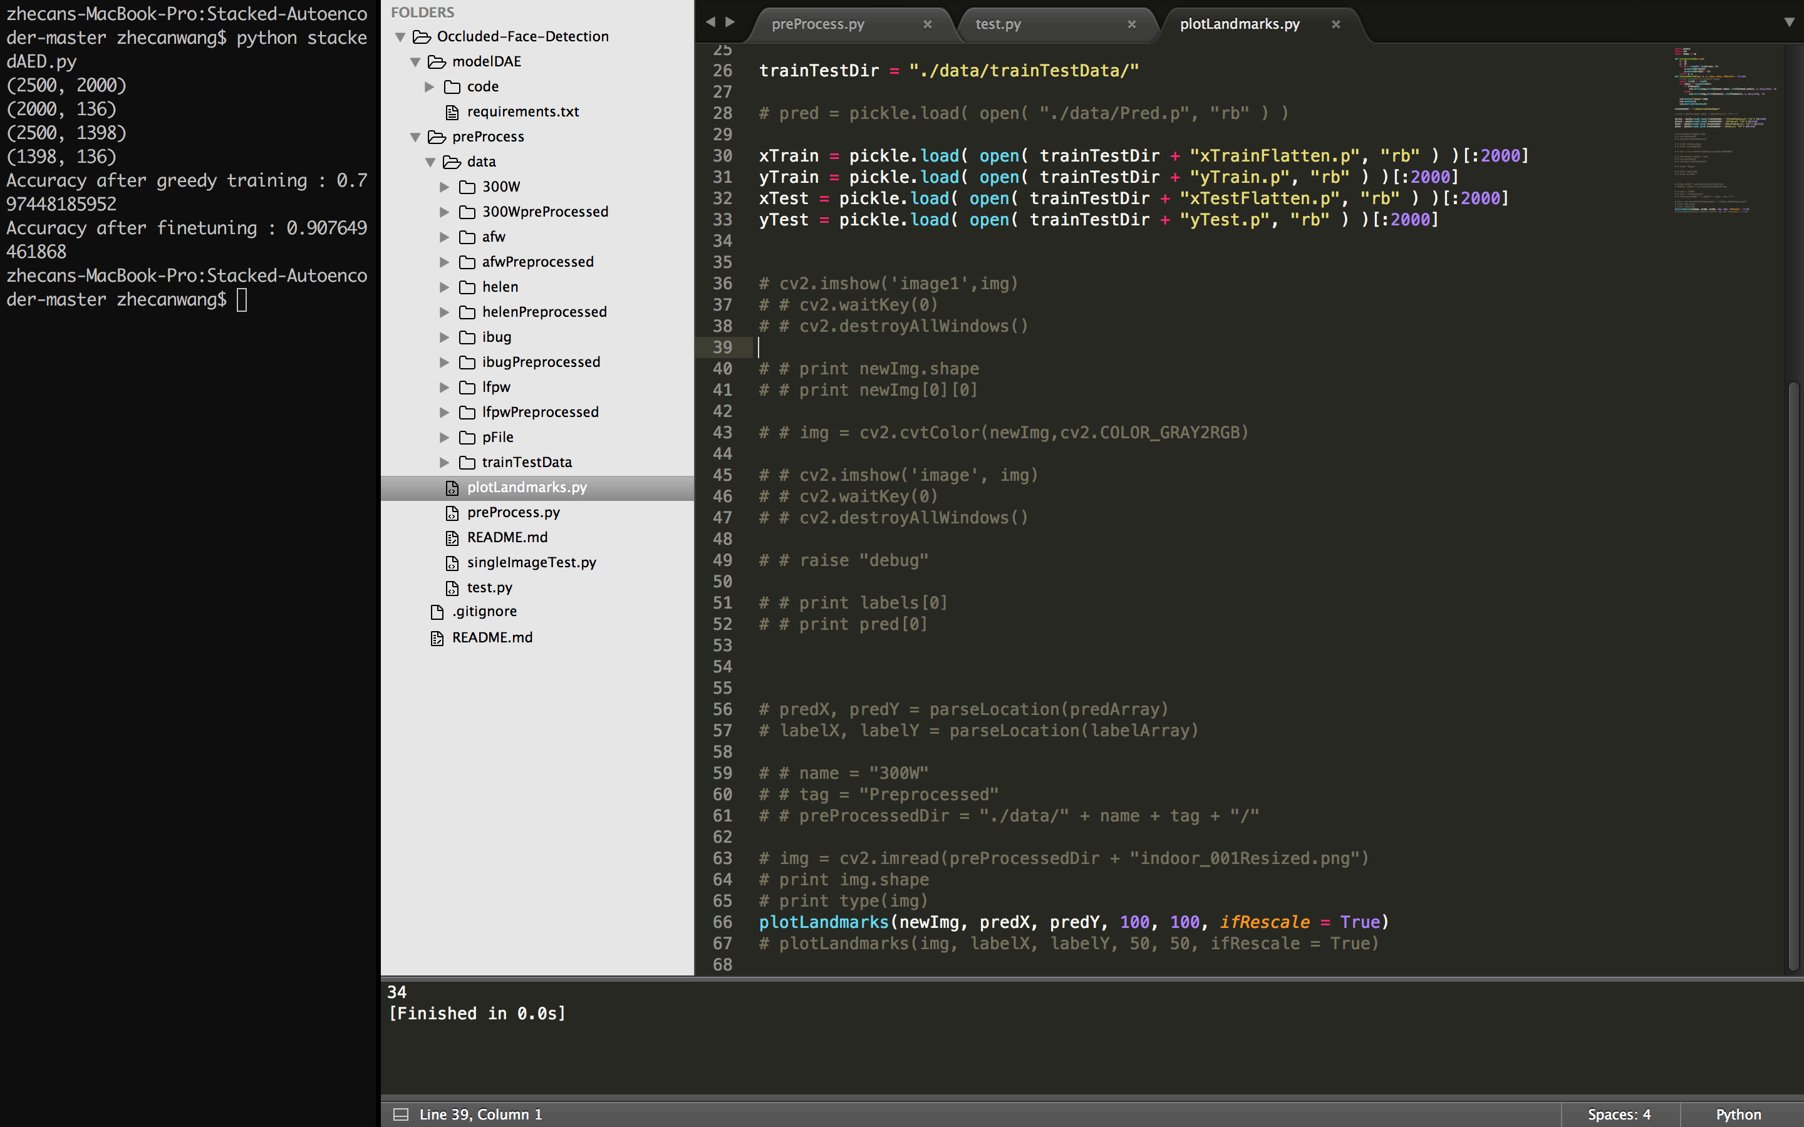

2000 data accuracy

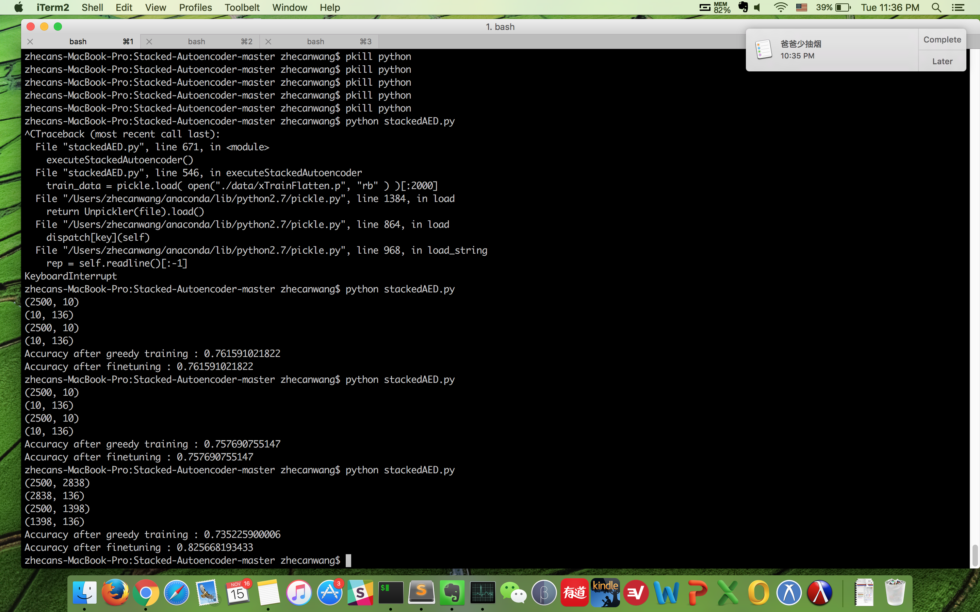

full data accuracy

Add interocular distance error method----------------------------------------------------------------------------

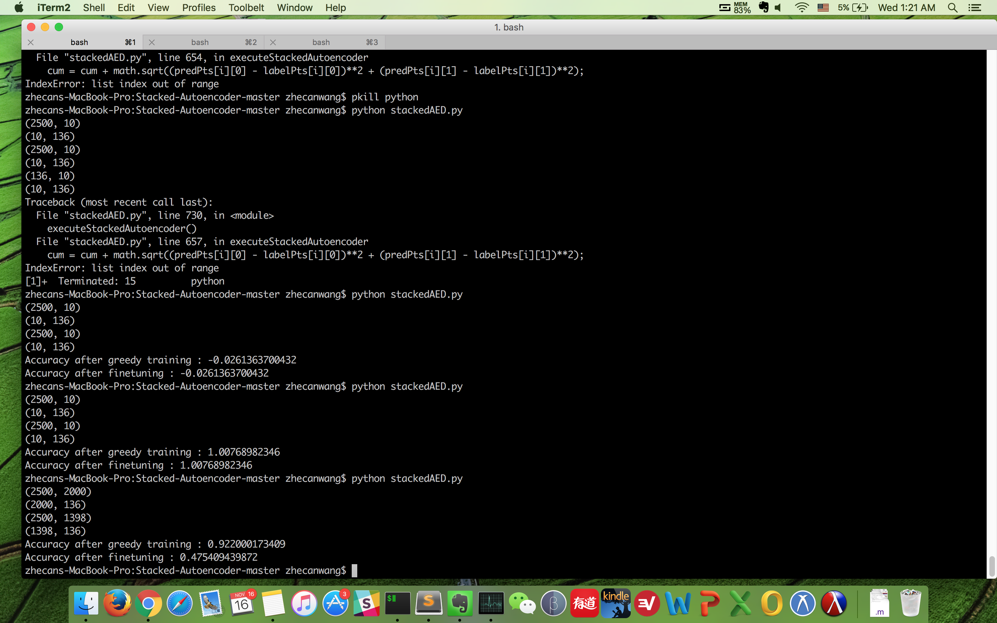

2000 data interocular_distance error

-------------------------------------------------------------------------------------------------------------------------------

Adding functions to generate derivative of images/ increasing data to solve overfitting problem

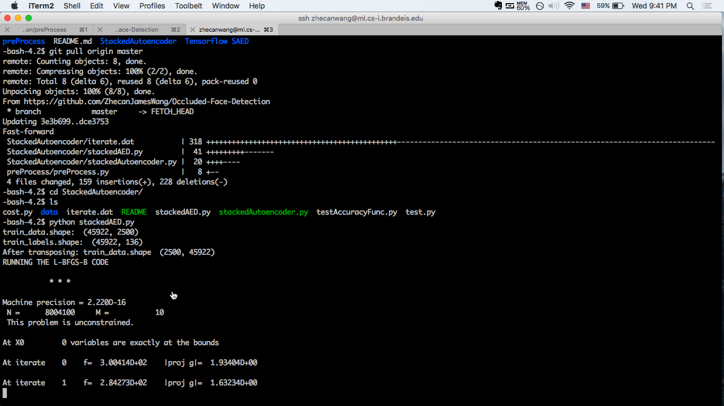

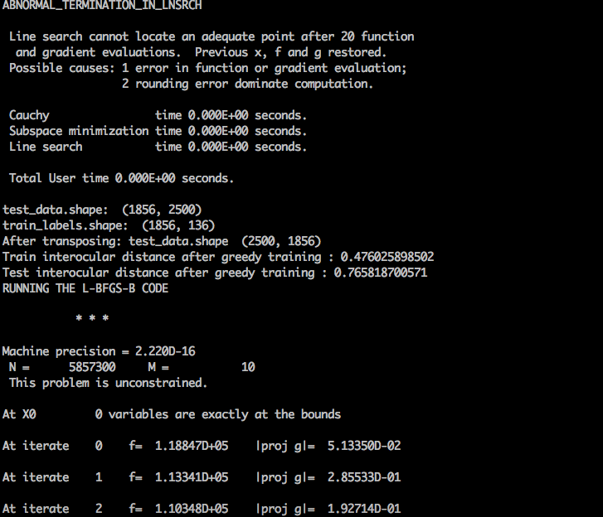

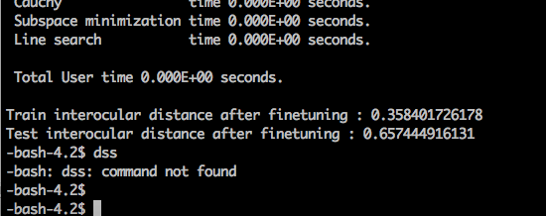

-bash-4.2$ python stackedAED.py

train_data.shape: (45922, 2500)

train_labels.shape: (45922, 136)

After transposing: train_data.shape (2500, 45922)

RUNNING THE L-BFGS-B CODE

* * *

Machine precision = 2.220D-16

N = 8004100 M = 10

This problem is unconstrained.

At X0 0 variables are exactly at the bounds

At iterate 0 f= 3.00414D+02 |proj g|= 1.93404D+00

At iterate 1 f= 2.84273D+02 |proj g|= 1.63234D+00

At iterate 2 f= 2.60758D+02 |proj g|= 2.82305D-01

At iterate 3 f= 2.55870D+02 |proj g|= 1.47259D-01

At iterate 4 f= 2.47975D+02 |proj g|= 1.07169D-01

At iterate 5 f= 2.39205D+02 |proj g|= 1.03666D-01

At iterate 6 f= 2.25615D+02 |proj g|= 9.79493D-02

At iterate 7 f= 1.97690D+02 |proj g|= 8.54053D-02

At iterate 8 f= 1.60657D+02 |proj g|= 6.51712D-02

At iterate 9 f= 1.31599D+02 |proj g|= 2.43114D-01

dss

Bad direction in the line search;

refresh the lbfgs memory and restart the iteration.

* * *

Tit = total number of iterations

Tnf = total number of function evaluations

Tnint = total number of segments explored during Cauchy searches

Skip = number of BFGS updates skipped

Nact = number of active bounds at final generalized Cauchy point

Projg = norm of the final projected gradient

F = final function value

* * *

N Tit Tnf Tnint Skip Nact Projg F

***** 10 50 2 0 0 2.431D-01 1.316D+02

F = 131.59857514605096

ABNORMAL_TERMINATION_IN_LNSRCH

Line search cannot locate an adequate point after 20 function

and gradient evaluations. Previous x, f and g restored.

Possible causes: 1 error in function or gradient evaluation;

2 rounding error dominate computation.

Cauchy time 0.000E+00 seconds.

Subspace minimization time 0.000E+00 seconds.

Line search time 0.000E+00 seconds.

Total User time 0.000E+00 seconds.

######################################## finish the first AED ########################################

######################################## save the recovered photo ########################################

RUNNING THE L-BFGS-B CODE

* * *

Machine precision = 2.220D-16

N = 2882500 M = 10

This problem is unconstrained.

At X0 0 variables are exactly at the bounds

At iterate 0 f= 2.80540D+02 |proj g|= 1.47691D+00

At iterate 1 f= 2.42101D+02 |proj g|= 1.37177D+00

At iterate 2 f= 1.18588D+02 |proj g|= 4.50242D-01

At iterate 3 f= 9.54393D+01 |proj g|= 2.95248D-01

At iterate 4 f= 7.86189D+01 |proj g|= 1.52392D-01

At iterate 5 f= 7.07693D+01 |proj g|= 7.08948D-02

At iterate 6 f= 5.88952D+01 |proj g|= 5.28851D-02

At iterate 7 f= 4.24910D+01 |proj g|= 4.21421D-02

At iterate 8 f= 2.24487D+01 |proj g|= 3.19166D-02

At iterate 9 f= 1.16767D+01 |proj g|= 1.29298D-01

At iterate 10 f= 8.49386D+00 |proj g|= 4.76450D-02

At iterate 11 f= 6.98167D+00 |proj g|= 4.10168D-02

At iterate 12 f= 6.79985D+00 |proj g|= 9.73144D-03

At iterate 13 f= 6.75360D+00 |proj g|= 5.44738D-03

At iterate 14 f= 6.70165D+00 |proj g|= 5.11930D-03

At iterate 15 f= 6.42745D+00 |proj g|= 6.12832D-03

At iterate 16 f= 6.23395D+00 |proj g|= 2.49765D-02

At iterate 17 f= 5.74798D+00 |proj g|= 2.39194D-02

At iterate 18 f= 5.43695D+00 |proj g|= 7.71829D-02

At iterate 19 f= 5.13845D+00 |proj g|= 2.60335D-02

At iterate 20 f= 4.82778D+00 |proj g|= 1.55981D-01

At iterate 21 f= 4.54083D+00 |proj g|= 6.39072D-02

At iterate 22 f= 4.49389D+00 |proj g|= 4.36193D-02

At iterate 23 f= 4.41595D+00 |proj g|= 3.21431D-02

At iterate 24 f= 4.20882D+00 |proj g|= 8.49554D-02

At iterate 25 f= 4.11915D+00 |proj g|= 3.30952D-02

At iterate 26 f= 4.01214D+00 |proj g|= 2.44101D-02

At iterate 27 f= 3.94992D+00 |proj g|= 2.64448D-02

At iterate 28 f= 3.90394D+00 |proj g|= 2.79118D-02

At iterate 29 f= 3.83994D+00 |proj g|= 3.26038D-02

At iterate 30 f= 3.75381D+00 |proj g|= 5.86442D-02

At iterate 31 f= 3.69998D+00 |proj g|= 2.83187D-02

At iterate 32 f= 3.65330D+00 |proj g|= 1.39618D-02

At iterate 33 f= 3.58444D+00 |proj g|= 2.88689D-02

At iterate 34 f= 3.53196D+00 |proj g|= 5.12223D-02

At iterate 35 f= 3.47900D+00 |proj g|= 3.28721D-02

At iterate 36 f= 3.37257D+00 |proj g|= 1.46936D-02

At iterate 37 f= 3.35467D+00 |proj g|= 2.67995D-02

At iterate 38 f= 3.33056D+00 |proj g|= 2.10807D-02

At iterate 39 f= 3.28643D+00 |proj g|= 1.34238D-02

At iterate 40 f= 3.26378D+00 |proj g|= 1.74144D-02

At iterate 41 f= 3.24064D+00 |proj g|= 1.48076D-02

At iterate 42 f= 3.07513D+00 |proj g|= 2.74529D-02

At iterate 43 f= 3.02829D+00 |proj g|= 5.24803D-02

At iterate 44 f= 2.98677D+00 |proj g|= 3.71803D-02

At iterate 45 f= 2.90321D+00 |proj g|= 2.76126D-02

At iterate 46 f= 2.79118D+00 |proj g|= 2.82497D-02

At iterate 47 f= 2.69190D+00 |proj g|= 4.08318D-02

At iterate 48 f= 2.59872D+00 |proj g|= 2.07313D-02

At iterate 49 f= 2.52989D+00 |proj g|= 1.94349D-02

At iterate 50 f= 2.49034D+00 |proj g|= 2.29391D-02

At iterate 51 f= 2.39076D+00 |proj g|= 1.95146D-02

At iterate 52 f= 2.30532D+00 |proj g|= 2.70138D-02

At iterate 53 f= 2.21958D+00 |proj g|= 1.71657D-02

At iterate 54 f= 2.12319D+00 |proj g|= 1.86972D-02

At iterate 55 f= 2.10501D+00 |proj g|= 1.74066D-02

At iterate 56 f= 2.08105D+00 |proj g|= 7.24511D-03

At iterate 57 f= 2.05826D+00 |proj g|= 1.48539D-02

At iterate 58 f= 2.02219D+00 |proj g|= 2.54107D-02

At iterate 59 f= 2.01166D+00 |proj g|= 1.01589D-02

At iterate 60 f= 2.00654D+00 |proj g|= 6.40085D-03

At iterate 61 f= 2.00200D+00 |proj g|= 5.77041D-03

At iterate 62 f= 1.99255D+00 |proj g|= 1.23088D-02

At iterate 63 f= 1.97656D+00 |proj g|= 1.77402D-02

At iterate 64 f= 1.96015D+00 |proj g|= 1.74092D-02

At iterate 65 f= 1.95156D+00 |proj g|= 8.04885D-03

At iterate 66 f= 1.94239D+00 |proj g|= 8.33515D-03

At iterate 67 f= 1.92912D+00 |proj g|= 1.97652D-02

At iterate 68 f= 1.91148D+00 |proj g|= 2.26942D-02

At iterate 69 f= 1.90585D+00 |proj g|= 1.48625D-02

At iterate 70 f= 1.89753D+00 |proj g|= 8.61970D-03

At iterate 71 f= 1.88953D+00 |proj g|= 1.36085D-02

At iterate 72 f= 1.88501D+00 |proj g|= 1.43350D-02

At iterate 73 f= 1.86793D+00 |proj g|= 9.16654D-03

At iterate 74 f= 1.86190D+00 |proj g|= 1.21620D-02

At iterate 75 f= 1.85490D+00 |proj g|= 1.34678D-02

At iterate 76 f= 1.84574D+00 |proj g|= 1.50882D-02

At iterate 77 f= 1.83213D+00 |proj g|= 1.81228D-02

At iterate 78 f= 1.82011D+00 |proj g|= 1.55152D-02

At iterate 79 f= 1.80362D+00 |proj g|= 1.53582D-02

At iterate 80 f= 1.78836D+00 |proj g|= 8.69339D-03

At iterate 81 f= 1.78239D+00 |proj g|= 1.11558D-02

At iterate 82 f= 1.77590D+00 |proj g|= 5.65612D-03

At iterate 83 f= 1.76478D+00 |proj g|= 1.25062D-02

At iterate 84 f= 1.75992D+00 |proj g|= 7.95786D-03

At iterate 85 f= 1.75722D+00 |proj g|= 8.12715D-03

At iterate 86 f= 1.75602D+00 |proj g|= 8.68340D-03

At iterate 87 f= 1.75157D+00 |proj g|= 8.86758D-03

At iterate 88 f= 1.74619D+00 |proj g|= 9.63695D-03

At iterate 89 f= 1.74253D+00 |proj g|= 9.24874D-03

At iterate 90 f= 1.73926D+00 |proj g|= 8.30082D-03

At iterate 91 f= 1.73661D+00 |proj g|= 8.26839D-03

At iterate 92 f= 1.73223D+00 |proj g|= 1.08785D-02

At iterate 93 f= 1.72607D+00 |proj g|= 1.49233D-02

At iterate 94 f= 1.72161D+00 |proj g|= 1.17782D-02

At iterate 95 f= 1.72014D+00 |proj g|= 1.05753D-02

At iterate 96 f= 1.71820D+00 |proj g|= 1.07959D-02

At iterate 97 f= 1.71597D+00 |proj g|= 1.08874D-02

At iterate 98 f= 1.70814D+00 |proj g|= 9.58024D-03

At iterate 99 f= 1.69982D+00 |proj g|= 1.40296D-02

At iterate 100 f= 1.69695D+00 |proj g|= 8.29154D-03

At iterate 101 f= 1.69310D+00 |proj g|= 4.16475D-03

At iterate 102 f= 1.69105D+00 |proj g|= 5.62934D-03

At iterate 103 f= 1.68979D+00 |proj g|= 7.67782D-03

At iterate 104 f= 1.68747D+00 |proj g|= 4.38857D-03

At iterate 105 f= 1.68687D+00 |proj g|= 5.43898D-03

At iterate 106 f= 1.68495D+00 |proj g|= 7.12119D-03

At iterate 107 f= 1.68414D+00 |proj g|= 3.94153D-03

At iterate 108 f= 1.68344D+00 |proj g|= 2.24378D-03

At iterate 109 f= 1.68311D+00 |proj g|= 2.09800D-03

At iterate 110 f= 1.68230D+00 |proj g|= 3.83702D-03

At iterate 111 f= 1.68102D+00 |proj g|= 6.59151D-03

At iterate 112 f= 1.67947D+00 |proj g|= 5.28407D-03

At iterate 113 f= 1.67942D+00 |proj g|= 4.60489D-03

At iterate 114 f= 1.67931D+00 |proj g|= 2.38068D-03

At iterate 115 f= 1.67910D+00 |proj g|= 2.16571D-03

At iterate 116 f= 1.67828D+00 |proj g|= 5.15509D-03

At iterate 117 f= 1.67751D+00 |proj g|= 5.70385D-03

At iterate 118 f= 1.67528D+00 |proj g|= 4.47265D-03

At iterate 119 f= 1.67528D+00 |proj g|= 3.16003D-03

At iterate 120 f= 1.67414D+00 |proj g|= 4.94163D-03

At iterate 121 f= 1.67325D+00 |proj g|= 7.68515D-03

At iterate 122 f= 1.66956D+00 |proj g|= 7.44120D-03

At iterate 123 f= 1.66923D+00 |proj g|= 5.72438D-03

At iterate 124 f= 1.66839D+00 |proj g|= 2.61042D-03

At iterate 125 f= 1.66681D+00 |proj g|= 7.32348D-03

At iterate 126 f= 1.66547D+00 |proj g|= 8.13829D-03

At iterate 127 f= 1.66402D+00 |proj g|= 2.54716D-03

At iterate 128 f= 1.66325D+00 |proj g|= 2.46071D-03

At iterate 129 f= 1.66292D+00 |proj g|= 4.29119D-03

At iterate 130 f= 1.66182D+00 |proj g|= 6.40805D-03

At iterate 131 f= 1.66176D+00 |proj g|= 5.35536D-03

At iterate 132 f= 1.66090D+00 |proj g|= 2.40078D-03

At iterate 133 f= 1.66088D+00 |proj g|= 2.63556D-03

At iterate 134 f= 1.66046D+00 |proj g|= 2.39195D-03

At iterate 135 f= 1.65968D+00 |proj g|= 3.58619D-03

At iterate 136 f= 1.65911D+00 |proj g|= 1.36719D-03

At iterate 137 f= 1.65904D+00 |proj g|= 1.03924D-03

At iterate 138 f= 1.65881D+00 |proj g|= 9.86909D-04

At iterate 139 f= 1.65872D+00 |proj g|= 1.92285D-03

At iterate 140 f= 1.65822D+00 |proj g|= 2.19011D-03

At iterate 141 f= 1.65797D+00 |proj g|= 2.51335D-03

At iterate 142 f= 1.65707D+00 |proj g|= 1.12157D-03

At iterate 143 f= 1.65653D+00 |proj g|= 2.11978D-03

At iterate 144 f= 1.65559D+00 |proj g|= 1.74805D-03

At iterate 145 f= 1.65559D+00 |proj g|= 1.74805D-03

* * *

Tit = total number of iterations

Tnf = total number of function evaluations

Tnint = total number of segments explored during Cauchy searches

Skip = number of BFGS updates skipped

Nact = number of active bounds at final generalized Cauchy point

Projg = norm of the final projected gradient

F = final function value

* * *

N Tit Tnf Tnint Skip Nact Projg F

***** 145 177 1 0 0 1.748D-03 1.656D+00

F = 1.6555931275322688

CONVERGENCE: REL_REDUCTION_OF_F_<=_FACTR*EPSMCH

Warning: more than 10 function and gradient

evaluations in the last line search. Termination

may possibly be caused by a bad search direction.

Cauchy time 0.000E+00 seconds.

Subspace minimization time 0.000E+00 seconds.

Line search time 0.000E+00 seconds.

Total User time 0.000E+00 seconds.

######################################## finish the second AED ########################################

RUNNING THE L-BFGS-B CODE

* * *

Machine precision = 2.220D-16

N = 721300 M = 10

This problem is unconstrained.

At X0 0 variables are exactly at the bounds

At iterate 0 f= 1.53580D+02 |proj g|= 1.41953D+00

At iterate 1 f= 1.33154D+02 |proj g|= 1.27593D+00

At iterate 2 f= 8.33003D+01 |proj g|= 2.84534D-01

At iterate 3 f= 7.38680D+01 |proj g|= 1.48650D-01

At iterate 4 f= 5.86575D+01 |proj g|= 5.87563D-02

At iterate 5 f= 4.37169D+01 |proj g|= 4.65118D-02

At iterate 6 f= 2.42999D+01 |proj g|= 2.98734D-02

At iterate 7 f= 9.82761D+00 |proj g|= 5.02360D-02

At iterate 8 f= 6.54005D+00 |proj g|= 1.07388D-01

At iterate 9 f= 3.59676D+00 |proj g|= 3.77790D-02

At iterate 10 f= 2.53985D+00 |proj g|= 2.34088D-01

At iterate 11 f= 2.52893D+00 |proj g|= 5.59336D-02

At iterate 12 f= 2.51766D+00 |proj g|= 2.57138D-02

At iterate 13 f= 2.49993D+00 |proj g|= 1.60265D-02

At iterate 14 f= 2.48457D+00 |proj g|= 2.22595D-02

At iterate 15 f= 2.32633D+00 |proj g|= 6.44018D-02

At iterate 16 f= 2.03303D+00 |proj g|= 9.55288D-02

At iterate 17 f= 1.32399D+00 |proj g|= 1.67508D-01

At iterate 18 f= 1.16935D+00 |proj g|= 1.92311D-01

At iterate 19 f= 1.15176D+00 |proj g|= 3.53254D-02

At iterate 20 f= 1.12828D+00 |proj g|= 5.93067D-03

At iterate 21 f= 1.11702D+00 |proj g|= 2.38449D-02

At iterate 22 f= 1.11002D+00 |proj g|= 1.32467D-02

At iterate 23 f= 1.10032D+00 |proj g|= 4.89520D-03

At iterate 24 f= 1.08992D+00 |proj g|= 4.88021D-03

At iterate 25 f= 1.06896D+00 |proj g|= 1.26986D-02

At iterate 26 f= 1.06644D+00 |proj g|= 4.48605D-03

At iterate 27 f= 1.05234D+00 |proj g|= 4.41077D-03

At iterate 28 f= 1.02310D+00 |proj g|= 1.33385D-02

At iterate 29 f= 9.98963D-01 |proj g|= 1.24841D-02

At iterate 30 f= 9.87609D-01 |proj g|= 2.28742D-02

At iterate 31 f= 9.67961D-01 |proj g|= 2.26152D-02

At iterate 32 f= 9.12751D-01 |proj g|= 2.25140D-02

At iterate 33 f= 7.15847D-01 |proj g|= 4.49601D-02

At iterate 34 f= 6.04080D-01 |proj g|= 3.44171D-02

At iterate 35 f= 5.02481D-01 |proj g|= 1.66965D-02

At iterate 36 f= 4.36585D-01 |proj g|= 4.19589D-02

At iterate 37 f= 4.19869D-01 |proj g|= 1.83777D-02

At iterate 38 f= 4.16001D-01 |proj g|= 3.37620D-03

At iterate 39 f= 4.11933D-01 |proj g|= 3.43087D-03

At iterate 40 f= 3.96721D-01 |proj g|= 1.54167D-02

At iterate 41 f= 3.78743D-01 |proj g|= 1.64867D-02

At iterate 42 f= 3.74897D-01 |proj g|= 1.54087D-02

At iterate 43 f= 3.71359D-01 |proj g|= 6.99493D-03

At iterate 44 f= 3.70739D-01 |proj g|= 2.77883D-03

At iterate 45 f= 3.70212D-01 |proj g|= 2.82197D-03

At iterate 46 f= 3.69263D-01 |proj g|= 5.34694D-03

At iterate 47 f= 3.66406D-01 |proj g|= 7.02911D-03

At iterate 48 f= 3.63098D-01 |proj g|= 1.47016D-02

At iterate 49 f= 3.60510D-01 |proj g|= 3.97832D-03

At iterate 50 f= 3.59643D-01 |proj g|= 3.83087D-03

At iterate 51 f= 3.59005D-01 |proj g|= 3.84862D-03

At iterate 52 f= 3.58488D-01 |proj g|= 3.85000D-03

At iterate 53 f= 3.55954D-01 |proj g|= 3.45428D-03

At iterate 54 f= 3.53628D-01 |proj g|= 5.35104D-03

At iterate 55 f= 3.51382D-01 |proj g|= 5.94126D-03

At iterate 56 f= 3.48781D-01 |proj g|= 4.32911D-03

At iterate 57 f= 3.47061D-01 |proj g|= 3.16140D-03

At iterate 58 f= 3.47060D-01 |proj g|= 2.53289D-03

At iterate 59 f= 3.47059D-01 |proj g|= 1.48113D-03

At iterate 60 f= 3.46990D-01 |proj g|= 1.59726D-03

At iterate 61 f= 3.46110D-01 |proj g|= 3.56684D-03

At iterate 62 f= 3.44379D-01 |proj g|= 4.38267D-03

At iterate 63 f= 3.40525D-01 |proj g|= 1.11437D-02

At iterate 64 f= 3.35719D-01 |proj g|= 1.01199D-02

At iterate 65 f= 3.34140D-01 |proj g|= 5.04885D-03

At iterate 66 f= 3.33038D-01 |proj g|= 3.49288D-03

At iterate 67 f= 3.32719D-01 |proj g|= 3.10864D-03

At iterate 68 f= 3.32002D-01 |proj g|= 2.94347D-03

At iterate 69 f= 3.30491D-01 |proj g|= 6.89870D-03

At iterate 70 f= 3.28463D-01 |proj g|= 7.66794D-03

At iterate 71 f= 3.27843D-01 |proj g|= 8.51620D-03

At iterate 72 f= 3.27269D-01 |proj g|= 3.20863D-03

At iterate 73 f= 3.27130D-01 |proj g|= 1.88509D-03

At iterate 74 f= 3.26947D-01 |proj g|= 2.79070D-03

At iterate 75 f= 3.26577D-01 |proj g|= 4.96842D-03

At iterate 76 f= 3.25590D-01 |proj g|= 7.75837D-03

At iterate 77 f= 3.23544D-01 |proj g|= 1.13009D-02

At iterate 78 f= 3.20714D-01 |proj g|= 9.46581D-03

At iterate 79 f= 3.19225D-01 |proj g|= 1.46808D-02

At iterate 80 f= 3.17803D-01 |proj g|= 5.39717D-03

At iterate 81 f= 3.16162D-01 |proj g|= 4.43704D-03

At iterate 82 f= 3.15258D-01 |proj g|= 6.23835D-03

At iterate 83 f= 3.14029D-01 |proj g|= 6.92061D-03

At iterate 84 f= 3.12312D-01 |proj g|= 9.87981D-03

At iterate 85 f= 3.12248D-01 |proj g|= 1.69795D-03

At iterate 86 f= 3.11749D-01 |proj g|= 1.99260D-03

At iterate 87 f= 3.10914D-01 |proj g|= 5.10523D-03

At iterate 88 f= 3.09700D-01 |proj g|= 7.62769D-03

At iterate 89 f= 3.07961D-01 |proj g|= 8.85225D-03

Bad direction in the line search;

refresh the lbfgs memory and restart the iteration.

At iterate 90 f= 3.07555D-01 |proj g|= 5.81763D-03

Bad direction in the line search;

refresh the lbfgs memory and restart the iteration.

* * *

Tit = total number of iterations

Tnf = total number of function evaluations

Tnint = total number of segments explored during Cauchy searches

Skip = number of BFGS updates skipped

Nact = number of active bounds at final generalized Cauchy point

Projg = norm of the final projected gradient

F = final function value

* * *

N Tit Tnf Tnint Skip Nact Projg F

***** 91 161 3 0 0 5.818D-03 3.076D-01

F = 0.30755488243293772

ABNORMAL_TERMINATION_IN_LNSRCH

Line search cannot locate an adequate point after 20 function

and gradient evaluations. Previous x, f and g restored.

Possible causes: 1 error in function or gradient evaluation;

2 rounding error dominate computation.

Cauchy time 0.000E+00 seconds.

Subspace minimization time 0.000E+00 seconds.

Line search time 0.000E+00 seconds.

Total User time 0.000E+00 seconds.

######################################## finish the third AED ########################################

RUNNING THE L-BFGS-B CODE

* * *

Machine precision = 2.220D-16

N = 54400 M = 10

This problem is unconstrained.

At X0 0 variables are exactly at the bounds

At iterate 0 f= 1.73283D+06 |proj g|= 8.43222D-02

At iterate 1 f= 8.96542D+05 |proj g|= 4.64017D-02

At iterate 2 f= 5.75941D+05 |proj g|= 4.97915D-03

At iterate 3 f= 5.21629D+05 |proj g|= 8.74097D-03

At iterate 4 f= 2.18472D+05 |proj g|= 1.49727D-02

At iterate 5 f= 1.32790D+05 |proj g|= 6.66946D-03

At iterate 6 f= 1.18945D+05 |proj g|= 7.99366D-04

Bad direction in the line search;

refresh the lbfgs memory and restart the iteration.

At iterate 7 f= 1.18865D+05 |proj g|= 4.33506D-04

At iterate 8 f= 1.18847D+05 |proj g|= 8.97495D-05

Bad direction in the line search;

refresh the lbfgs memory and restart the iteration.

* * *

Tit = total number of iterations

Tnf = total number of function evaluations

Tnint = total number of segments explored during Cauchy searches

Skip = number of BFGS updates skipped

Nact = number of active bounds at final generalized Cauchy point

Projg = norm of the final projected gradient

F = final function value

* * *

N Tit Tnf Tnint Skip Nact Projg F

54400 9 78 3 0 0 8.975D-05 1.188D+05

F = 118846.54321434897

ABNORMAL_TERMINATION_IN_LNSRCH

Line search cannot locate an adequate point after 20 function

and gradient evaluations. Previous x, f and g restored.

Possible causes: 1 error in function or gradient evaluation;

2 rounding error dominate computation.

Cauchy time 0.000E+00 seconds.

Subspace minimization time 0.000E+00 seconds.

Line search time 0.000E+00 seconds.

Total User time 0.000E+00 seconds.

test_data.shape: (1856, 2500)

train_labels.shape: (1856, 136)

After transposing: test_data.shape (2500, 1856)

Train interocular distance after greedy training : 0.476025898502

Test interocular distance after greedy training : 0.765818700571

RUNNING THE L-BFGS-B CODE

* * *

* * *

Machine precision = 2.220D-16

N = 5857300 M = 10

This problem is unconstrained.

At X0 0 variables are exactly at the bounds

At iterate 0 f= 1.18847D+05 |proj g|= 5.13350D-02

At iterate 1 f= 1.13341D+05 |proj g|= 2.85533D-01

At iterate 2 f= 1.10348D+05 |proj g|= 1.92714D-01

At iterate 3 f= 1.06368D+05 |proj g|= 8.06585D-02

At iterate 4 f= 1.01781D+05 |proj g|= 5.79538D-02

At iterate 5 f= 9.94559D+04 |proj g|= 4.06027D-02

At iterate 6 f= 9.87832D+04 |proj g|= 1.57011D-02

At iterate 7 f= 9.78165D+04 |proj g|= 2.18745D-02

At iterate 8 f= 9.57578D+04 |proj g|= 7.76573D-02

At iterate 9 f= 9.09048D+04 |proj g|= 1.89782D-01

At iterate 10 f= 8.13474D+04 |proj g|= 3.25435D-01

At iterate 11 f= 7.41617D+04 |proj g|= 4.68818D-02

At iterate 12 f= 7.38212D+04 |proj g|= 4.12839D-02

At iterate 13 f= 7.37961D+04 |proj g|= 5.89145D-02

At iterate 14 f= 7.36791D+04 |proj g|= 1.00952D-02

At iterate 15 f= 7.36735D+04 |proj g|= 4.51976D-03

At iterate 16 f= 7.36729D+04 |proj g|= 5.94602D-03

At iterate 17 f= 7.36728D+04 |proj g|= 7.65124D-03

At iterate 18 f= 7.36718D+04 |proj g|= 1.49414D-02

At iterate 19 f= 7.36713D+04 |proj g|= 1.70219D-02

At iterate 20 f= 7.36686D+04 |proj g|= 2.20220D-02

At iterate 21 f= 7.36675D+04 |proj g|= 2.68226D-02

At iterate 22 f= 7.36655D+04 |proj g|= 2.90374D-02

Bad direction in the line search;

refresh the lbfgs memory and restart the iteration.

* * *

Tit = total number of iterations

Tnf = total number of function evaluations

Tnint = total number of segments explored during Cauchy searches

Skip = number of BFGS updates skipped

Nact = number of active bounds at final generalized Cauchy point

Projg = norm of the final projected gradient

F = final function value

* * *

N Tit Tnf Tnint Skip Nact Projg F

***** 23 145 2 0 0 2.904D-02 7.367D+04

F = 73665.509894839590

ABNORMAL_TERMINATION_IN_LNSRCH

Line search cannot locate an adequate point after 20 function

and gradient evaluations. Previous x, f and g restored.

Possible causes: 1 error in function or gradient evaluation;

2 rounding error dominate computation.

Cauchy time 0.000E+00 seconds.

Subspace minimization time 0.000E+00 seconds.

Line search time 0.000E+00 seconds.

Total User time 0.000E+00 seconds.

Train interocular distance after finetuning : 0.358401726178

Test interocular distance after finetuning : 0.657444916131